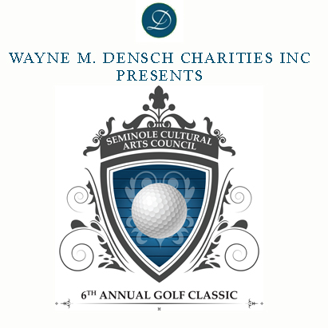

2020 SPONSORSHIP LEVELS

$3,000 LUNCH SPONSOR
- Free $1,200 Annual Arts Lover Membership
- 3 Foursomes – includes breakfast and lunch
$2,000 BREAKFAST SPONSOR
- Free $1,000 Annual Corp. Patron Membership
- 2 Foursomes – includes breakfast and lunch

$1,000 BEVERAGE SPONSOR
- Free $500 Annual Arts Angel Membership
- 1 Foursome – includes breakfast and lunch
$1,000 PRIZE SPONSOR
- Free $500 Annual Arts Angel Membership
- 1 Foursome – includes breakfast and lunch

$500 FOURSOME
- Four golfers – includes breakfast and lunch

$125 SINGLE GOLFER
- Individual golfer – includes breakfast and lunch

$100 HOLE SPONSOR
- Corporate recognition during event and in promotion
- Link to Sponsors corporate website on SCAC website

Formed in 1994 as a 501(c)3 non-profit organization, the Seminole Cultural Arts Council (SCAC) is best known as a source of funding and information for local arts and cultural agencies and activities. SCAC advocates for the preservation of cultural and historic heritage including performing, literary, and visual arts and sciences. SCAC serves to promote and support the arts through art appreciation and community involvement. All proceeds from SCAC Inaugural Golf Classic support arts and cultural programs in Seminole County.

Friday, October 9, 2020 – 8:00 am registration, 9:00 am shotgun start
Mayfair Country Club
3536 Country Club Road, Sanford, FL 32773

For more information, contact Donna Bundy, 407.302.1099 or info@seminoleculturalarts.org

SPONSORSHIP COMMITMENT

Contact Name: ______________________________________________________ Phone #: __________________________________
Company Name: ____________________________________________ Email: _____________________________________________
Street Address: ___________________________________________________________________________________________________
City, State & Zip: __________________________________________________________________________________________________
Company Web Address: _________________________________________________________________________________________

Sponsorship Level:

_____ LUNCH SPONSOR / $3,000*
_____ BREAKFAST SPONSOR / $2,000*
_____ BEVERAGE SPONSOR / $1,000*
_____ PRIZE SPONSOR / $1,000*
_____ GOLF FOURSOME / $500*
_____ INDIVIDUAL GOLFER / $125*
_____ HOLE SPONSOR / $100

*If your sponsorship includes a foursome(s) or if you are an individual golfer, please provide your name or the names of your guests. If all guest names are not available at this time, please provide primary sponsor name(s), and forward remaining guest names by September 25, 2019:

1. __________________________________________ 2. _________________________________________ 3. ________________________________________
__________________________________________ _________________________________________ ________________________________________
__________________________________________ _________________________________________ ________________________________________
__________________________________________ _________________________________________ ________________________________________

_____ Enclosed is a check made payable to SCAC, Inc.
_____ Please provide an invoice for me
_____ Please charge my _____ VISA _____ MasterCard _____ AMEX _____ Discover
Card Number: _________________________________________ Exp. Date: ________________ CCV: _____________
Billing Address: _________________________________________________________________________________________
(Street) (City) (State) (ZipCode)
Signature: __________________________________________________________

Deadline for sponsorship commitment forms is September 23, 2020 to ensure inclusion in collateral and press materials.

Submit this form to the Seminole Cultural Arts Council (SCAC)
By mail to P.O. Box 28, Sanford, FL 32772-0028 or via email to info@seminoleculturalarts.org

